Folk Voice Band Duo
Philip and Birgit Ages
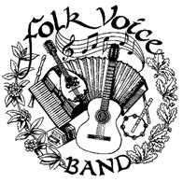
Performing at
Café Louvre in Edmonds
210 5th Ave S, Edmonds, WA 98020
Saturday July 18th 2026 from 1-3pm
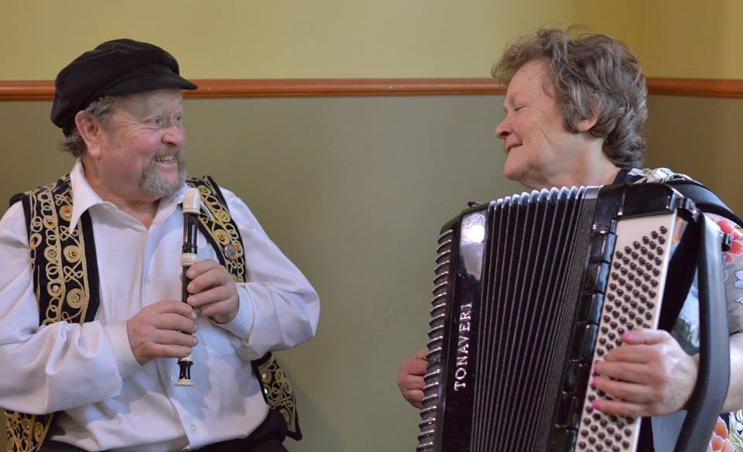
Folk Voice Band
Birgit @ (206) 947-8393 or Philip @ (206) 947-6918
e-mail folkvoice@folkvoiceband.com
Web Address http://www.folkvoiceband.com/

